HMS/CF

2 October 2013

Dear Parent/ Carer

As you will be aware from the media, the teacher trade unions NUT and NASUWT will be taking industrial action on Thursday 17 October 2013.

The action (a one day strike) will also result in whole school closures across the country in London, the South East and South West.

As a result of this action Longhill school will be closed to students for the whole day.

The decision to close the school or send pupils home is never taken lightly, but in this instance, where staff have elected to take lawful industrial action, I will have no choice but to take appropriate steps to ensure the health, safety and well-being of all pupils.

We are aware that school closures inconvenience parents and carers and so I am writing to give you advance notice of the impact of the action on this school.

Thank you for your patience and understanding.

Yours sincerely

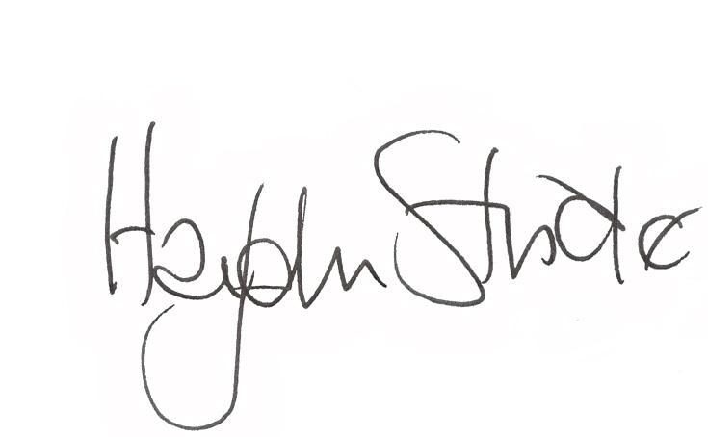

Haydn Stride
Headteacher

