A Great Day Out at Longhill
Longhill High School’s Drama society once again wowed audiences with a top rate performance on Tuesday evening. This year’s winter show, Our Day Out, was staged by 30 year 10 and 11 students, who worked incredibly hard over the past two months with drama teachers Jo Ellis and Donna Rhodes to create the fast paced, fun-filled show. The Willy Russell play follows a group of tear-away students who are part of the ‘Progress Class’, a class designed to help those students who are struggling with their reading and writing, as they embark on their first ever trip out of the city. Students are taken to Conwy castle in Wales, stopping on the way at the Zoo, the beach and the pier. Of course, chaos and adventures follow the class wherever they go!
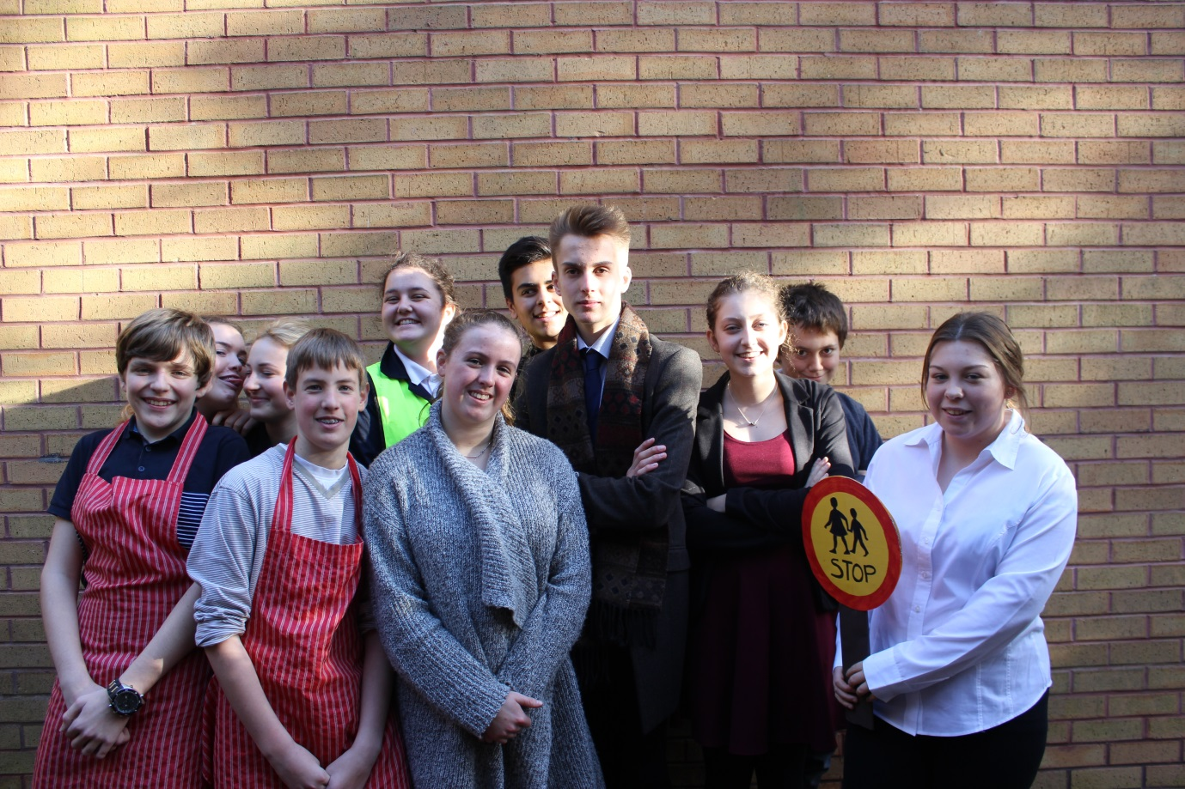
The one-night-only performance was well received by parents and students alike and everyone involved had a very enjoyable evening. Departments across the school supported the production by helping with scenery, props, sound, lighting and publicity. “It’s not just the actors who make a great performance,” said Head of Drama, Jo Ellis, “Everyone can get involved in some way and putting on this show has been a great collaborative experience for both staff and students.”

