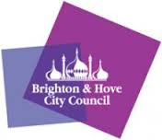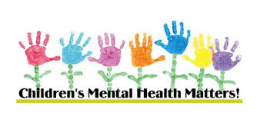

Dear Parents/Carers,

Do you have a child or young person at school in Brighton & Hove?

**If you have any concerns about their Emotional Mental Health and Wellbeing you are invited to talk to a Primary Mental Health Worker from the Schools Wellbeing Service.**

* Telephone consultations are available during the Christmas holiday period on:

Monday 23rd December

Tuesday 24th December

Thursday 2nd January

Friday 3rd January

**Tel: 01273 293331**

You will need to leave a message on the number above and a Primary Mental Health Worker will call you back.

**This is not a crisis number – if you require immediate support you need to contact your GP, call CAMHS duty care on 03003040061 or go direct to A&E**

**For information on different services available, please visit findgetgive.com**