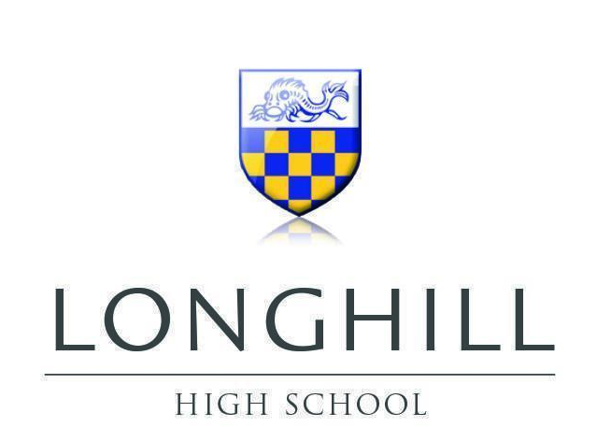

Relationships and Sex Education (RSE) Policy

Lead Authors | S Trelawny (Faculty Lead SMSC), S Keating Assistant Headteacher
Policy Source
Ratified Date | To be ratified
Review Cycle | Annually
Next Review Date | Policy to be reviewed in line with new statutory guidance taking effect from September 2026
Changes | Minor

1. Policy Statement

Longhill High School is committed to providing high‐quality, age-appropriate Relationships and Sex Education (RSE) that promotes informed decision making, healthy attitudes, and respectful relationships. Our RSE provision forms an integral part of the PSHE curriculum and has been designed in line with statutory requirements and local guidance published by the Department for Education and Brighton and Hove City Council.

2. Introduction and Rationale

RSE is recognised as a core component of a modern, holistic education. At Longhill High School our approach reflects the DfE’s statutory guidance on ‘Relationships Education, Relationships and Sex Education (RSE) and Health Education’ (2025/26 version – new version in force for teaching from September 2026) and aligns with Brighton and Hove Council policies. This policy acknowledges that:

- All secondary schools in England must provide Relationships and Sex Education that is factual, balanced, and sensitive to the diverse needs of pupils.

- Recent updates have emphasized age-appropriateness with clear guidelines on when certain topics should be introduced and the importance of enabling parents to be informed about the content and methodology used in lessons.

The aim is to support our pupils’ personal development and help them navigate increasingly complex social, digital, and emotional landscapes.

3. Aims and Values

The core aims of our RSE policy are to:

Develop Understanding: Ensure that all pupils understand the fundamentals of healthy relationships, the nature of respect and consent and the legal framework surrounding sexual behavior and personal safety.

Promote Wellbeing: Enhance pupil well-being through the accurate dissemination of information about physical, emotional and sexual health.

Encourage Inclusivity: Celebrate diversity by addressing the spectrum of relationships and identities within a framework where all pupils feel safe, respected and valued.

Foster Critical Thinking: Equip pupils with the skills needed to evaluate digital influences, peer pressure and media representations critically.

Support Parental Involvement: Maintain transparency with parents and carers by providing clear information on lesson content and methodologies, ensuring their right to engage with and review the materials used.

Our values are embedded in respect, equality, openness and the commitment to meeting statutory and local standards.

4. Curriculum Content and Delivery

4.1 Scope of Content

The RSE curriculum for pupils aged 11–16 will encompass the following key areas:

Healthy Relationships:

- Understanding different types of relationships (friendships, romantic relationships, family relationships)

- Characteristics of healthy, supportive and respectful relationships

- The importance of equality and mutual respect

Personal and Emotional Development:

- Self-awareness and developing personal identity

- Emotional literacy and resilience

- Recognising and managing feelings in oneself and in relationships

Sexual Health Education:
- Physical changes during puberty and an understanding of human reproduction

- Information about consent, boundaries and personal safety

- Guidance on contraception and sexual health services, emphasizing legal responsibilities and safeguarding

Digital and Social Media Influences:

- Identifying potential risks in online relationships and interactions

- Strategies for managing digital footprints and online safety

- Critical discussion on media representations of relationships and sexuality

4.2 Teaching Methodology

Lessons will be delivered through a variety of evidence-based approaches to maximise engagement and understanding:

Interactive and Participatory Learning:

- Group discussions, role-playing and scenario-based learning to simulate real-life situations.

- Use of age-appropriate multimedia resources that reflect modern digital influences.

Safe and Respectful Learning Environment:

- Lessons are conducted in a confidential and supportive atmosphere where every pupil feels able to express themselves.

- Teachers use language and content that is adjusted to the maturity of the pupils following guidance on appropriate timing for more sensitive topics.

Integration into PSHE:

- RSE is woven into the wider PSHE curriculum, ensuring that discussions about relationships, health and well-being are consistently reinforced.

- Emphasis is placed on reflective learning, where pupils can question, debate and consolidate their understanding.

5. Safeguarding and Support

Ensuring the safety and well-being of every pupil is our paramount concern. Accordingly:

Designated Safeguarding Lead (DSL):

- Ms Debbie Winfield (DSL) will continue to oversee all safeguarding concerns related to RSE.

- Clear protocols are in place so that pupils, parents and staff know where to direct concerns about inappropriate content or potential abuse.

Sensitive Issues:

- Topics such as sexual consent, abuse, and digital safety are handled with particular care and teachers undergo regular training on safeguarding best practices.

- Pupils will be informed about the support available, including how to report concerns confidentially within both school and local community settings.

Inclusive Practice:

Additional support is provided for pupils with special educational needs or those from vulnerable backgrounds, ensuring accessibility and appropriateness of content.

6. Parental Engagement and Transparency

Longhill High School recognises the importance of active parental engagement in RSE. Our approach is based on:

Transparent Communication:

- Parents are provided with clear information about the topics covered, the teaching methods used, and the evidence guiding our practice.

- The school maintains open channels for feedback and discussion, including access to lesson plans and resource materials upon request.

Parental Rights:

- We respect parental views by ensuring that any requests regarding the withdrawal of a pupil from particular aspects of the curriculum are handled in line with statutory requirements and with the pupil’s best interests at heart.

- Information sessions and newsletters will be used to keep parents informed of any updates or changes resulting from statutory reviews.

7. Staff Training and Professional Development

To deliver high-quality RSE all teaching staff involved in PSHE receive regular, up-to-date training on:
- Current Statutory Guidance:
Ongoing professional development based on updates from the Department for Education’s statutory guidance and local advice from Brighton and Hove City Council.
- Safeguarding and Inclusive Practice:
Training in managing sensitive discussion topics, identifying safeguarding concerns early and supporting pupils from diverse backgrounds.
- Innovative Pedagogies:
Sharing best practices for engaging pupils through interactive methods and adapting content to current digital trends and social developments.

8. Implementation and Monitoring

8.1 Implementation
Curriculum Planning:
- The PSHE curriculum team led by Mr Sean Trelawny (Faculty Lead SMSC) integrates RSE topics systematically throughout KS3 and KS4.
- Lesson plans and resource materials are developed in consultation with statutory guidance, expert bodies (e.g., the PSHE Association) and local partners.
Resource Allocation:
- The school ensures that appropriate resources—ranging from digital content to guest speakers—are available to enhance the learning experience.
Cross-Departmental Collaboration:
- Regular meetings between senior leadership, subject leads and the PSHE department ensure coherence and consistency across the curriculum.

8.2 Monitoring and Evaluation
Feedback Mechanisms:
- We actively seek feedback from pupils, parents and teachers to assess the efficacy of our RSE provision.
- Surveys, focus groups and lesson observations support continuous improvement.

Review Cycle:
- The policy will be reviewed at least every three years or in response to significant changes in statutory guidance or local policy developments.
- Amendments will be communicated to the school community promptly.

9. Policy Review and Amendments
Longhill High School is committed to keeping this policy under regular review. The next formal review is scheduled for Summer 2026, with interim evaluations conducted as necessary in light of updates from central government, Brighton and Hove City Council and safeguarding authorities. All feedback from stakeholders will be considered to ensure our practice remains current and effective.

APPENDIX

Relationships and Sex education at Longhill High School- Topics covered

Year 7 | Year 8 | Year 9
- Physical and emotional changes at puberty  - Menstruation & FGM  - Personal hygiene  - Being positive & self-esteem  - Consent & boundaries  - Friendships – what makes a good friend?  - Respect & relationships  - Managing friendships & relationships  - Peer pressure & influences | - Sexual organs – vocabulary and functions  - Sexual orientation  - What is gender  - Healthy, respectful  relationships  - What is love?  - Introduction to  contraception  - Periods and the menstrual cycle | - FGM & the law  - Sexual consent & the law  - Pleasure & masturbation  - Delaying sexual activity  - Why have sex?  - Relationships & partners  - What are STIs  - Body confidence

Year 10 | Year 11
- FGM  - Sexting, nudes & ‘dick pics’  - Online pornography  - Domestic abuse and domestic violence  - Sexualisation of the media  - Unhealthy relationships, sexual assault and rape  - Porn and its impact on society  - Safe sex – developing negotiation and assertiveness skills. Condom skills | - Peer on peer abuse  - Fertility  - Alcohol, parties & bad choices  - Importance of sexual health  - Revisiting contraception  - Respect, love & relationships  - Revisiting STIs

